*PREDICTING THE ENERGY OUTPUT OF WIND TURBINE BASED ON*



*WEATHER CONDITION*

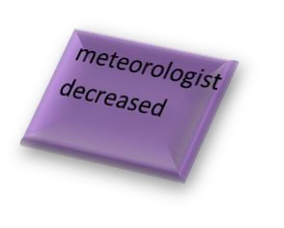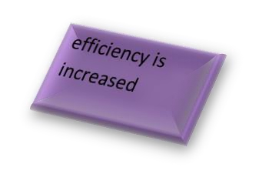

|  |  |  |
| --- | --- | --- |
| **1.CUSTOMER SEGMENT(CS)**  ***The person who needs to identify the amount of energy produce from wind turbine based on the speed*** | **6.CUSTOMER CONSTRAINT**  Customer . They  can only can’t able  login to access  Only Admin the wind  turbine.  can able to  access the | **5.AVAILABLE SOLUTION** |

|  |  |  |
| --- | --- | --- |
| **2.JOB-TO-BE-DONE / PROBLEM**  Meteorologist manually take every value  Calculate the value for theoretical power  Time taking process  Any kind of error will cost a huge amount to the government | **9.PROBLEM ROOT CAUSE**  Map weather data to energy production  data that is publicly available for weather  Wind farm used to give prediction of the energy output. | **7. BEHAVIOUR**  **GAIN**:  Inexhaustible Non pollutant  **PAIN:**  Unpredictability  It is a threat to wildlife |





|  |  |  |  |
| --- | --- | --- | --- |
| **3. TRIGGERS** | | **10. YOUR SOLUTION** | **8. CHANNELS OF BEHAVIOUR** |
|  | | Examine the impact of weather | **ONLINE:** |
| **4. EMOTIONS:**  Stressed& confused | Troubled &worried | Building a predict |  |
| the energy output |  |
| of city |  |